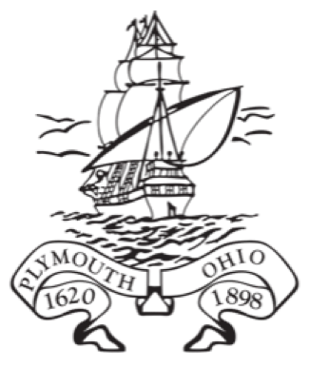
Society of Mayflower Descendants in Ohio Scholarship Application Form

Deadline: March 1, 2026

Name
Address
Phone
Email
Name of High School
Graduation Year
Institution attending in the Fall 2026 and Address

GPA
Major/Field of Study
Expected Degree and Graduation Date
Mayflower Ancestor
Applicant’s Ohio Society number or Junior number
Applicant’s Colony

Applicant’s Signature Date
by signing above you are declaring you wrote the essay and the application information is correct to the best of your knowledge.

Instructions:
All applications should include the following:
- The scholarship application form
- The essay with signed cover page
- Two sealed letters of recommendation

Materials must be Postmarked by March 1, 2026 and mailed to:
Heather Horton, Scholarship Chair
1718 Melanzana Dr.
Hilliard, OH 43026

Questions:
Email SMDOHedu@hlhorton.org

